**Introduction**

Eclipse is commonly known as Integrated Development Environment for Java. Eclipse is an open source multi-language software development environment, composed of integrated development environment (IDE) with a flexible plug-in system. Eclipse is a software designed to manage IDE for Java language. It is helpful for programming applications for Windows platforms.

**Algorithms Introduction**

# Analysis of algorithms

Analysis of algorithms is associated with algorithm’s efficiency with respect to execution time and memory usage. The program performance is measured by the efficiency of the program in terms of memory required to execute and the time needed to run the program. The efficiency of an algorithm depends on two factors:

1. Memory used (Space efficiency).
2. Execution time (Time efficiency)

Space complexity: It is the measure of minimum amount of memory, which is essential to run the program completely and efficiently.

Time complexity: It is measured purely on how fast a given algorithm is executed. Since the efficiency of an algorithm is measured usually using time, word time complexity is often associated with an algorithm.

The execution time for an algorithm depends on various factors such as

1. Speed of a computer
2. Choice of the language to implement the algorithm
3. Compiler used while generating the target code and so on.

## Worst-case, Best-case and Average-case efficiencies

* Worst case efficiency: The efficiency of an algorithm for the worst case input of size n for which the algorithm takes longest time to execute among all possible inputs of that size is called worst case efficiency. In the worst case analysis, the algorithm runs for the longest duration among all possible inputs for a given size. Here, maximum numbers of steps are executed for that input.
* Best case efficiency: The efficiency of an algorithm for the input of size n for which the algorithm takes least time during execution among all possible inputs of that size is called best case efficiency. In the best case, the algorithm runs fastest for the input specified.
* Average case efficiency: Average number of steps required for execution for randomized or typical input.

## Techniques used in design of algorithm

* Brute Force
* Divide and Conquer
* Decrease and Conquer
* Transform and Conquer
* Space and Time Tradeoffs
* Dynamic Programming
* Greedy Method
* Backtracking
* Approximation Algorithm

Brute Force Method: The straight forward method or approach to solve a given problem based on the problem’s statement and definitions of the concepts involved is called Brute Force technique.

## Divide and Conquer Method: It is one of the important techniques of solving certain types of problems. Divide-and-conquer is a top-down technique for designing algorithms that consists of dividing the problem into smaller subprograms hoping that the solutions of the subprograms are easier to find and then combine the partial solutions into the solution of the original problem .

Decrease and Conquer Method: These techniques are slight variation of divide and conquer method. In divide and conquer method we divide the problem size into n/2. In decrease and conquer method the problem size may be decremented by a constant or decremented by a constant factor or decremented by a variable size. Thus, there are three variations of decrease-and-conquer technique namely:

1. Decrease by a constant
2. Decrease by a constant factors
3. Variable size decrease.

Space and Time Tradeoffs Method: If an application has time constraint, we may have to choose an algorithm which takes less time may be by using extra space. In such situation, it is required to pre-process the input data and obtain the additional information. The two techniques based on pre-processing of data thereby increasing the speed of the algorithm are:

* Input enhancement technique
* Pre-structuring technique

Input enhancement technique: In this technique it is required to preprocess the input data and additional information is obtained based on the application. The additional information thus obtained may be stored in the form of a table which may be used by an algorithm to get the required result with less time. This technique is called Input enhancement techniques.

Pre-structuring technique: The other technique that uses extra space thereby reducing the execution time is called pre-structuring technique.

Dynamic Programming: Dynamic programming, similar to the divide-and-conquer technique, solves the problems by combining the solutions to sub problems. Dynamic programming is a stage-wise search method suitable for optimization problems whose solutions may be viewed as the result of a sequence of decisions. The advantage of Dynamic Programming is that once a subproblem is solved, the result in a table and never recalculated. From this table, we can obtain a solution to the larger sub problems.

Greedy Method: A greedy algorithm is an algorithm that always tries to find the best solution for each each-problem, with the hopes that this will yield a good solution for the problem as a whole. Greedy algorithm is simple and straight forward and is easy to invent, easy to implement and most of the time quite efficient. Greedy algorithm always makes the choice that looks best at the moment.

Backtracking: The principal idea of this algorithm is to construct solutions one component at a time and evaluate such partially constructed candidates as follows. If a partially constructed solution ca be developed further without violating the problem’s constraints, it is done by taking the first remaining legitimate option for the next component. If there is no legitimate option for the next component, no alternatives for any remaining component need to be considered. In this case, the algorithm backtracks to replace the last component of the partially constructed solution with its next option.

Approximation Algorithm: There is radically different way of dealing with difficult optimization problem: solve them approximately by a fast algorithm. This approach is particularly appealing for applications where a good but not necessarily optimal solution will suffice. Besides, in real life applications, we often have to operate with inaccurate data to begin with. Under such circumstances, going for an approximate solution can be a particularly sensible choice. A heuristic is a common- sense rule drawn from experience rather than from a mathematically proved assertion.

**Object-oriented programming (OOP) languages are designed to overcome these problems.**

1. The basic unit of OOP is a class, which encapsulates both the static properties and dynamic operations within a "box", and specifies the public interface for using these boxes. Since classes are well encapsulated,it is easier to reuse these classes. In other words, OOP combines the data structures and algorithms of a software entity inside the same box.
2. OOP languages permit higher level of abstraction for solving real-life problems. The traditional procedural language (such as C and Pascal) forces you to think in terms of the structure of the computer (e.g. memory bits and bytes, array, decision, loop) rather than thinking in terms of the problem you are trying to solve.
3. The OOP languages (such as Java, C++ and C#) let you think in the problem space, and use software objects to represent and abstract entities of the problem space to solve the problem.

**Object-Oriented technology has many benefits:**

1. Ease in software design as you could think in the problem space rather than the machine's bits and bytes. You are dealing with high-level concepts and abstractions. Ease in design leads to more productive software development.
2. Ease in software maintenance: object-oriented software are easier to understand, therefore easier to test, debug, and maintain.
3. Reusable software: you don't need to keep re-inventing the wheels and re-write the same functions for different situations. The fastest and safest way of developing a new application is to reuse existing codes - fully tested and proven codes.

**Java Program Structure ( Designing & Implementing an Application)**

Package Details ----------------------------------------------------🡪import java.io.*

class className ---------------------------------------------------🡪class Sum

{

Data Members ----------------------------------------------------🡪int a, b, c;

User_Defined methods; ----------------------------------------🡪void display();

public static void main(String args[])

{

Block of Statements; --------------------------🡪System.out.println(“Hello Java”);

}

}

A package is a collection of classes, interfaces and sub-packages. A sub package contains collection of classes,

interfaces and sub-sub packages etc. java.lang.*; package is imported by default and this package is known as default package.

Class is keyword used for developing user defined data type and every java program must start with a concept of class.

"ClassName" represent a java valid variable name treated as a name of the class each and every class name in java is treated as user-defined data type.

Data member represents either instance or static they will be selected based on the name of the class.

User-defined methods represents either instance or static they are meant for performing the operations either once or each and every time.

Each and every java program starts execution from the main() method. And hence main() method is known as program driver.

Since main() method of java is not returning any value and hence its return type must be void.

Since main() method of java executes only once throughout the java program execution and hence its nature must be static.

Since main() method must be accessed by every java programmer and hence whose access specifier must be public.

Each and every main() method of java must take array of objects of String.

Block of statements represents set of executable statements which are in term calling user-defined methods are containing business-logic.

The file naming conversion in the java programming is that which-ever class is containing main() method, that class name must be given as a file name with an extension .java.

**Compile and Run Java Program**

**Steps For compile Java Program:**

o First Save Java program with same as class name with .java extension.

Example: Sum.java

o Compile: javac Filename.java

Example, javac Sum.java

**Steps For Run Java Program:**

o For run java program use java tool.

o Run by: java Filename

**PROGRAM EXPLANATION:**

**1 A) Create a Java class called Student with the following details as variables within it.**

**(i) USN**

**(ii) Name**

**(iii) Branch**

**(iv) Phone**

**Write a Java program to create n Student objects and print the USN, Name, Branch, and Phone of these objects with suitable headings.**

Procedure:

Step 1: Crate a Java File of a Student Class with Data Members & Methods

-------------------------------------- -- Student.java -----------------------------------------

import java.io.*; --------------_ // Packages

import -----------------------------_ // Packages

// Define Student Class

public class Student {

private String USN; // usn

private String Name; // name

private String Branch; // Branch

private int phone; // phone number

// construct a new student with given fields

public Student(String USN, String Name, String Branch, int Phone) {

this.USN = USN;

this.Name = Name;

this.Branch = Branch;

this.Phone = Phone;

}

// sample client

public static void main(String[] args) {

// initialize an array that holds n objects of type Student

Student[] students = new Student[n];

// read in the data

for (int i = 0; i < n; i++) {

String USN = StdIn.readString();

String Name = StdIn.readString();

String Branch = StdIn.readString();

int Phone = StdIn.readInt();

students[i] = new Student(USN, Name, Branch, Phone);

}

// print results

System.out.println("Student USN"+"\t\t\t"+"Name"+"\t\t\t"+"Branch"+"\t\t\t"+"Phone");

for (int i = 0; i < n; i++) {

// Print Out Puts

}

}

}

Step 2: Compile the Source Program

$javac Student.java // Generates “Student.class” (byte code for jvm)

Step 3: Run Java Application(Program)

$java Student

**B) Write a Java program to implement the Stack using arrays. Write Push(), Pop(), and Display() methods to demonstrate its working.**

**Step 1:** Crate a Java File of a Stack Class with Data Members & Methods ( --- Stack.java --- )

import java.util.Arrays; ------------------------------------_ Packages

public class Stack{

private int top; // Data Members

int size; // Data Members

int[] stack ; // Data Members

// Member function to initialize Array

public Stack(int arraySize){

// Initialize Size

}

// Member function to insert element into an Array

public void push(int value){

// Check Status of Stack (FULL) & Insert New Element

}

// Member function to Delete an element from Stack Array

public void pop(){

// Check Emptiness of Stack Array

}

}

public void display(){

for(int i=0;i<=top;i++){

// Display Contents of Stack Array

}

}

}

**Step 2:** Create a StackDemo Implementation file ( --- StackDemo.java --- )

public class StackDemo {

public static void main(String[] args) {

Stack newStack = new Stack(n); // // Initialize an array that holds n objects of type Stack

// Invoke Different Operations

newStack.push(element); // Inserting New Element to Stack Top

newStack.display(); // Displaying Status of Stack

newStack.pop(); // Removing an Element of Stack Top

newStack.display(); // Displaying Status of Stack

}

}

**Step 3: Compile Both Files ( Stack.java & StackDemo.java)**

**$** javac Stack.java StackDemo.java

**Step 4: Run the StackDemo**

**$** java StackDemo

**2 A. Design a superclass called Staff with details as StaffId, Name, Phone, Salary. Extend this class by writing three subclasses namely Teaching (domain, publications), Technical (skills), and Contract (period).**

**Write a Java program to read and display at least 3 staff objects of all three categories.**

The Program illustrates Inheritance or Superclass - Subclass Concept:

Inheritance allows one class to reuse the functionality provided by its superclasses. The extends clause in a class declaration establishes an inheritance relationship between two classes.

**Note** that A class may directly extend only one superclass. Each of those subclasses may itself have several subclasses

**Step 1:** Create a Superclass **“Staff”** with StaffId, Name, Phone, Salary.

class staff

{

String StaffId;

String Name;

int Phone;

int Salary;

staff(String Id, String name, int fone,int sal )

{

//Initialize

}

void Display()

{

// Display the Details

}

}

**Step 2:** Create a Subclass **“Teaching”** with domain, publications as additional data members and Extends staff

(Superclass).

class Teaching extends staff

{

String domain;

String publications;

Teaching(String SID, String SName, int fone, int sal,, String dom,String pub)

{

Super(SID, SName, fone, sal); //initialize super data members

// initialize local data members

}

void Display()

{

super.Display(); // call super class display

// Display Local Data

}

}

**Step 3:** Create a Subclass **“Technical”** with skills as additional data member and Extends staff (Superclass).

class Technical extends staff

{

String skills;

Technical(String SID, String SName, int fone, int sal,, String skills)

{

Super(SID, SName, fone, sal); //initialize super data members

// initialize local data members

}

void Display()

{

super.Display(); // call super class display

// Display Local Data

}

}

**Step 4:** Create a Subclass **“Contract”** with period as additional data member and Extends staff (Superclass).

class Contract extends staff

{

int period;

Contract(String SID, String SName, int fone, int sal,, int Period)

{

Super(SID, SName, fone, sal); //initialize super data members

// initialize local data members

}

void Display()

{

super.Display(); // call super class display

// Display Local Data

}

}

**Step 5:** Create a **DemoStaff** to Demonstrate implementation of Inheritance.

class DemoStaff

{

public static void main(String args[])

{

staff sObj = new staff("Default Staff Details");

Teaching tObj = new Teaching("Teaching Staff 1"); // invoke multiple

Technical techObj = new Technical("Technical staff 1"); // invoke multiple

System.out.println("Staff Default :");

sObj.Display();

// call display for different instances.

}

}

**Step 6: Compile All Java Files ( Stack.java & StackDemo.java)**

**$** javac DemoStaff.java

**Step 4: Run the StackDemo**

**$** java DemoStaff

**2 B. Write a Java class called Customer to store their name and date_of_birth. The date_of_birth format should be dd/mm/yyyy. Write methods to read customer data as <name, dd/mm/yyyy> and display as <name, dd, mm, yyyy> using StringTokenizer class considering the delimiter character as “/”.**

**Step 1:** Create CustomerInfo & Implementer Class Customer

import java.io.*;

import java.util.StringTokenizer;

class CustomerInfo

{

String Name;

String Date_Of_Birth;

// Read Date of Birth in(dd/mm/yyyy) format

getDetails(String FullName,Strint DateOfBirth){

}

// Use StringTokenizer to split the fields od Date & asign them to proper variables with parsing

// Display Details

void DisplayDetails(String name,int dd,int mm,int yyyy){

}

}

class Customer

{

public static void main(String args[])

{

CustomerInfo c=new CustomerInfo();

// Read Name & Date_Of_Birth in (dd/mm/yyyy) Format

c.getDetails(name,dd/mm/yyyy);

// Print the Name & Date

c.DisplayDetails(name,dd,mm,yyyy);

}

}

**Step 2:** Compile & Run

**$**javac Customer.java

**$**java Customer

**3 A. Write a Java program to read two integers a and b. Compute a/b and print, when b is not zero. Raise an exception when b is equal to zero.**

**Step 1:** Create a Class for Compute Division with Exception Handling.

// Add imports (Packages)

class Division {

public static void main(String[] args) {

int a, b, result;

// Read Inputs a & b

// try block

try {

result = a / b;

System.out.println("Result = " + result);

}

// catch block

catch (ArithmeticException e) {

System.out.println("Exception caught: Division by zero.");

}

}

}

**Step 2:** Compile & Run the Program

**$**javac ComputeDivision.java

**$**java ComputeDivision

**3 B. Write a Java program that implements a multi-thread application that has three threads. First thread generates a random integer for every 1 second; second thread computes the square of the number and prints; third thread will print the value of cube of the number.**

**Step 1:** Create Different Thread Classes & an Implementing Class

import java.util.*; // Add Required Packages

class square implements Runnable

{

public int x;

public void run()

{

// Print SQUARE of x

}

}

class Cube implements Runnable

{

public int x;

public void run()

{

// Print CUBE of x

}

}

class RandomNumGen extends Thread

{

public void run()

{

Random r = new Random();

// Generate Random Numbers

num = r.nextInt(100);

// print Generated Random Number

// Start 2nd Thread to Print SQUARES

Thread t2 = new Thread(new square(num));

t2.start();

// Start 3rd Thread to Print CUBES

Thread t3 = new Thread(new Cube(num));

t3.start();

}

}

public class ThreadImplementer

{

public static void main(String[] args)

{

RandomNumGen R = new RandomNumGen();

R.start();

}

}

**Step 2:** Compile & Run

**$**javac ThreadImplementer.java

**$**java ThreadImplementer

**4:Sort a given set of *n* integer elements using Quick Sort method and compute its time complexity. Run the program for varied values of *n*> 5000 and record the time taken to sort. Plot a graph of the time taken versus *n*on graph sheet. The elements can be read from a file or can be generated using the random number generator. Demonstrate using Java how the divide-and-conquer method works along with its time complexity analysis: worst case, average case and best case.**

**Quick Sort:**

* It is an algorithm of Divide & Conquer algorithm which relies on partition operation.
* To partition an array, an element pivot is choosen, all smaller elements are moved before pivot and all greater elements are moved after the pivot. This can be done efficiently in linear time . Then recursively sorting can be done for the lesser and greater sublists.
* **Sort the array in ascending order.**
* **Method:**

**Divide:** Rearrange the elements and split arrays into two sub-arrays and an element in between search that each element in left sub array is less than or equal to the average element and each element in the right sub- array is larger than the middle element.

**Conquer:** Recursively, sort two sub arrays.

**Combine:** Combine the already sorted array.

**The steps involved are:**

**Pivot**

1. Picks an element called the "pivot".

**Partition**

2. Rearrange the array elements in such a way that the all values lesser than the pivot should come before the pivot and all the values greater than the pivot should come after it.

This method is called partitioning the array. At the end of the partition function, the pivot element will be placed at its sorted position.

**Recursive**

3. Do the above process recursively to all the sub-arrays and sort the elements.

**Pseudo code:**

**Algorithm:quicksort(a[low……..high])**

//sorts subarray by quicksort

//input:a subarray a[low…high] of a[0…n-1] defined by its left and right indices low and high

if low<high

j <- partition(a[low…high]) //j is split position

quicksort(a,low,j-1)

quicksort(a,j+1,high)

**Algorithm:partition(a[low….high]** ) // Partition algorithm rearranges the sub arrays in a place.

//partitions a subarray using its elements as a pivot

//Input:a subarray a[low…high] Of a[0…n-1] defined by its left and right indices low and //high(low<high)

i <- low

j <- high

key <- a[low]

repeat

repeat i <- i+1 until (a[i]<=key)

repeat j <- j-1 until (a[j]>key)

swap(a[i],a[j])

until i<j

swap(a[j],a[low])

returnj

**Implementation:**

• Call a function to generate list of random numbers (integers)

• Record clock time

• Call a Quick sort function to sort n randomly generated elements.

• Record clock time.

• Measure difference in clock time to get elapse time to sort n elements using Quick sort

• Print the Sorted ‘ n’ elements and time taken to sort.

• Repeat the above steps for different n values.

**Pseudo code:**

1. Declare time variables

2. record the start time in terms of seconds before sorting

3. Generate ‘n ‘ elements randomly using rand () function

4. Call Quick sort function to sort n elements

// Sorts a sub array by quick sort

//Input : A sub array A[l..r] of A[0..n-1] ,defined by its left and right indices l

//and r

// Output : The sub array A[l..r] sorted in non decreasing order

if low<high

j <- partition(a[low…high]) //j is split position

quicksort(a,low,j-1)

quicksort(a,j+1,high)

**ALGORITHM** Partition (A[l…r])

//Partition a sub array by using its first element as a pivot

// Input : A sub array A[l…r] of A[0…n-1] defined by its left and right indices l and // r (l <

r)

// Output : A partition of A[l…r], with the split position returned as this function’s value

i <- low

j <- high

key <- a[low]

repeat

repeat i <- i+1 until (a[i]<=key)

repeat j <- j-1 until (a[j]>key)

swap(a[i],a[j])

until i<j

swap(a[j],a[low])

return j

5. record the end time in terms of seconds after sorting

6. Calculate the time in terms of seconds required to sort n elements using Quick

sort

elapse_time = (end-start);

Print "elapse_time”.

7. Repeat the above steps for different ‘n’ values

Result:

- Randomly generated ‘n’ numbers are sorted using Quick sort.

- Calculate the elapse time required for different ‘n’ elements

* **Example:**

**65, 40,75,80 ,45**

|  |  |  |  |  |
| --- | --- | --- | --- | --- |
| **65** | **40** | **75** | **80** | **45** |
| **pivot ,i** | **i** |  |  | **j** |

|  |  |  |  |  |
| --- | --- | --- | --- | --- |
| **65** | **40** | **75** | **80** | **45** |
| **pivot** | **i** |  |  | **j** |

|  |  |  |  |  |
| --- | --- | --- | --- | --- |
| 65 | 40 | 75 | 80 | 45 |
| pivot |  | i |  | J |

|  |  |  |  |  |
| --- | --- | --- | --- | --- |
| 65 | 40 | 45 | 80 | 75 |
| pivot |  | i |  | j |

|  |  |  |  |  |
| --- | --- | --- | --- | --- |
| 65 | 40 | 45 | 80 | 75 |
| pivot |  |  | i | j |

|  |  |  |  |  |
| --- | --- | --- | --- | --- |
| 65 | 40 | 45 | 80 | 75 |
| pivot |  |  | i j |  |

|  |  |  |  |  |
| --- | --- | --- | --- | --- |
| 65 | 40 | 45 | 80 | 75 |
| pivot |  | j | i |  |

|  |  |  |  |  |
| --- | --- | --- | --- | --- |
| 45 | 40 | 65 | 80 | 75 |
|  |  | pivot |  |  |

Elements towards the left pivot are lesser and towards right are greater.

This forms two subarrays.

Apply same procedure to the subgraphs.

|  |  |
| --- | --- |
| 45 | 40 |
| pivot | i,j |

|  |  |
| --- | --- |
| 40 | 45 |
|  |  |

**5. Sort a given set of *n* integer elements using Merge Sort method and compute its time complexity. Run the program for varied values of *n*> 5000, and record the time taken to sort. Plot a graph of the time taken versus *n*on graph sheet. The elements can be read from a file or can be generated using the random number generator. Demonstrate using Java how the divide and conquer method works along with its time complexity analysis: worst case, average case and best case.**

Merge Sort:

-works on Divide and Conquer method.

- The general concept is that we first break/divide the list into two smaller lists of roughly the same size, and then use merge sort recursively on the sub problems, until they cannot subdivide anymore (i.e. when they contain zero or one elements). One complete list is formed from merging these sublist.Then, we can merge by stepping through the lists in linear time.

* Output-in ascending order

**Pseudo code**

1. Declare time variables

2. Generate ‘n ‘ elements randomly

3. record the start time in terms of seconds before sorting

4. Call Merge sort function to sort n element

Algorithm : simple_merge(a,low,mid,high)

//purpose: merge two sorted arrays into single sorted array

//input: a[] is sorted vector of both m and n elements.

//output : c[] is sorted vector obtained after merging the elements of m and n

k -> i -> low

j -> mid + 1

while(i<=mid && j< high)

if(a[i]<a[j])

c[k] <- a[i]

i <- i+1

k <- k+1

else

c[k] <- a[j]

j <- j+1

k <- k+1

end if

end while

while(i<= mid)

c[k <- k+1] = a[i <- i+1]

end while

while(j<=high)

c[k <- k+1] = a[j <- j+1]

end while

for i <- low to high do

a[i] <- c[i]

end for

Algorithm : merge_sort(a,low,high)

//purpose : sort the elements of the array between the lower bound and upper bound

//input : a[] is the unsorted array with low and high as the bounds

//output: a[] is the sorted vector

if(low>high)return

mid <- (low+high)/2

merge_sort(a,low,mid)

merge_sort(a,mid+1,high)

simple_merge(a,low,mid,high)

end if

5. record the end time in terms of seconds after sorting

6. Calculate the time interms of seconds required to sort n elements using Merge

7. Repeat the above steps for different ‘n’ values

Result:

- Randomly generated ‘n’ numbers are sorted using Merge sort.

- Calculate the elapse time required for different ‘n’ elements

Example :

40, 60 ,30, 50 ,10,20

|  |  |  |  |  |  |
| --- | --- | --- | --- | --- | --- |
| **40** | **60** | **30** | **50** | **10** | **20** |
| **Low** |  |  |  |  | **High** |

Low=0

High=n-1

Calculate mid=(low+high)/2

mid=2

Divide the complete elements from (low to mid) and (mid+1 to high)

Step1:

|  |  |  |
| --- | --- | --- |
| 40 | 60 | 30 |
| Low | mid=(0+2)/2=1 | high |

|  |  |  |
| --- | --- | --- |
| 50 | 10 | 20 |
| Low | mid=(0+2)/2=1 | high |

Step2:

|  |  |
| --- | --- |
| 40 | 60 |
| Low | High |

|  |
| --- |
| 30 |
|  |

|  |  |
| --- | --- |
| 50 | 10 |
| Low | high |

|  |
| --- |
| 20 |
|  |

Step3:

|  |
| --- |
| 40 |
|  |

|  |
| --- |
| 60 |
|  |

|  |
| --- |
| 30 |
|  |

|  |
| --- |
| 50 |
|  |

|  |
| --- |
| 10 |
|  |

|  |
| --- |
| 20 |
|  |

Here,we have divided the complete elements to sub elements -------Divide part- we have divided complex problem into smaller problems.

Now we have to conquer them by merging each elements.(comparing)

Compare 40,60 [ if (40<60) put it on LHS of the bigger element] already in sorted order.

|  |  |
| --- | --- |
| 40 | 60 |
| I | |

|  |  |
| --- | --- |
| 10 | 50 |
| I | |

|  |  |  |
| --- | --- | --- |
| 30 | 40 | 60 |
| J | i | |

i

|  |  |  |
| --- | --- | --- |
| 10 | 20 | 50 |
| I | J | i |

j

compare i and j

10,20,30,40,50,60

**6.Implement in Java, the 0/1 Knapsack problem using (a) Dynamic Programming method (b)**

**Greedy method.**

Theory:

## ****Knapsack Problem-****

You are given the following-

* A knapsack (kind of shoulder bag) with limited weight capacity.
* Few items each having some weight and value.

**The problem states-**

Which items should be placed into the knapsack such that-

* The value or profit obtained by putting the items into the knapsack is maximum.
* And the weight limit of the knapsack does not exceed.

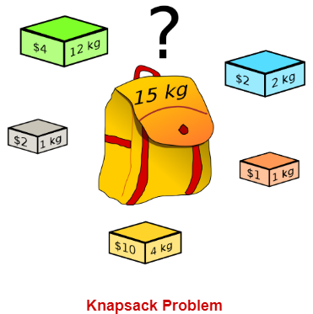

Knapsack problem has the following two variants-

1. Fractional Knapsack Problem
2. 0/1 Knapsack Problem

## **0**/1 Knapsack Problem-****

In 0/1 Knapsack Problem,

* As the name suggests, items are **indivisible here**.
* We **can not take the fraction of any item**.
* We have **to either take an item completely or leave it completely**.
* It is solved using dynamic programming approach.

**Problem:** How to pack the knapsack to achieve maximum total value of packed items?

**USING: a. Dynamicprogramming**

Consider-

* Knapsack weight capacity = w
* Number of items each having some weight and value = n

0/1 knapsack problem is solved using dynamic programming in the following steps-

### **Step-01:**

* Draw a table say ‘T’ with (n+1) number of rows and (w+1) number of columns.
* Fill all the boxes of 0th row and 0th column with zeroes as shown-

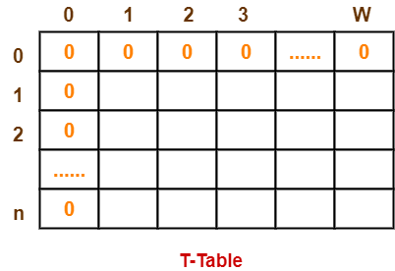

### **Step-02:**

 Start filling the table row wise top to bottom from left to right.

Use the following formula-

**T (i , j) = max { T ( i-1 , j ) , valuei + T( i-1 , j – weighti) }**

Here, T(i , j) = maximum value of the selected items if we can take items 1 to i and have weight restrictions of j.

 This step leads to completely filling the table.

* Then, value of the last box represents the maximum possible value that can be put into the knapsack.

### **Step-03:**

 Consider the last column of the table.

* Start scanning the entries from bottom to top.
* On encountering an entry whose value is not same as the value stored in the entry immediately above it, mark the row label of that entry.
* After all the entries are scanned, the marked labels represent the items that must be put into the knapsack.

PROBLEM:

Find the optimal solution for the 0/1 knapsack problem making use of dynamic programming approach. Consider-

n = 4

w = 5 kg

(w1, w2, w3, w4) = (2, 3, 4, 5)

(b1, b2, b3, b4) = (3, 4, 5, 6)

### **Given-**

* Knapsack capacity (w) = 5 kg
* Number of items (n) = 4

### **Step-01:**

 Draw a table say ‘T’ with (n+1) = 4 + 1 = 5 number of rows and (w+1) = 5 + 1 = 6 number of columns.

* Fill all the boxes of 0th row and 0th column with 0.

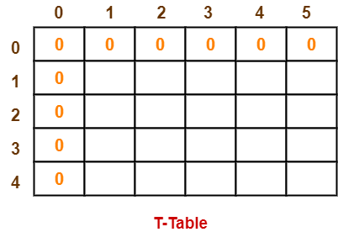

### **Step-02:**

Start filling the table row wise top to bottom from left to right using the formula-

**T (i , j) = max { T ( i-1 , j ) , valuei + T( i-1 , j – weighti) }**

### **Finding T(1,1)-**

We have,

* i = 1
* j = 1
* (value)i = (value)1 = 3
* (weight)i = (weight)1 = 2

Substituting the values, we get-

T(1,1) = max { T(1-1 , 1) , 3 + T(1-1 , 1-2) }

T(1,1) = max { T(0,1) , 3 + T(0,-1) }

T(1,1) = T(0,1) { Ignore T(0,-1) }

T(1,1) = 0

### **Finding T(1,2)-**

We have,

* i = 1
* j = 2
* (value)i = (value)1 = 3
* (weight)i = (weight)1 = 2

Substituting the values, we get-

T(1,2) = max { T(1-1 , 2) , 3 + T(1-1 , 2-2) }

T(1,2) = max { T(0,2) , 3 + T(0,0) }

T(1,2) = max {0 , 3+0}

T(1,2) = 3

### **Finding T(1,3)-**

We have,

* i = 1
* j = 3
* (value)i = (value)1 = 3
* (weight)i = (weight)1 = 2

Substituting the values, we get-

T(1,3) = max { T(1-1 , 3) , 3 + T(1-1 , 3-2) }

T(1,3) = max { T(0,3) , 3 + T(0,1) }

T(1,3) = max {0 , 3+0}

T(1,3) = 3

### **Finding T(1,4)-**

We have,

* i = 1
* j = 4
* (value)i = (value)1 = 3
* (weight)i = (weight)1 = 2

Substituting the values, we get-

T(1,4) = max { T(1-1 , 4) , 3 + T(1-1 , 4-2) }

T(1,4) = max { T(0,4) , 3 + T(0,2) }

T(1,4) = max {0 , 3+0}

T(1,4) = 3

### **Finding T(1,5)-**

We have,

* i = 1
* j = 5
* (value)i = (value)1 = 3
* (weight)i = (weight)1 = 2

Substituting the values, we get-

T(1,5) = max { T(1-1 , 5) , 3 + T(1-1 , 5-2) }

T(1,5) = max { T(0,5) , 3 + T(0,3) }

T(1,5) = max {0 , 3+0}

T(1,5) = 3

### **Finding T(2,1)-**

We have,

* i = 2
* j = 1
* (value)i = (value)2 = 4
* (weight)i = (weight)2 = 3

Substituting the values, we get-

T(2,1) = max { T(2-1 , 1) , 4 + T(2-1 , 1-3) }

T(2,1) = max { T(1,1) , 4 + T(1,-2) }

T(2,1) = T(1,1) { Ignore T(1,-2) }

T(2,1) = 0

**Finding T(2,2)-**

We have,

* i = 2
* j = 2
* (value)i = (value)2 = 4
* (weight)i = (weight)2 = 3

 Substituting the values, we get-

T(2,2) = max { T(2-1 , 2) , 4 + T(2-1 , 2-3) }

T(2,2) = max { T(1,2) , 4 + T(1,-1) }

T(2,2) = T(1,2) { Ignore T(1,-1) }

T(2,2) = 3

### **Finding T(2,3)-**

We have,

* i = 2
* j = 3
* (value)i = (value)2 = 4
* (weight)i = (weight)2 = 3

Substituting the values, we get-

T(2,3) = max { T(2-1 , 3) , 4 + T(2-1 , 3-3) }

T(2,3) = max { T(1,3) , 4 + T(1,0) }

T(2,3) = max { 3 , 4+0 }

T(2,3) = 4

**Finding T(2,4)-**

We have,

* i = 2
* j = 4
* (value)i = (value)2 = 4
* (weight)i = (weight)2 = 3

Substituting the values, we get-

T(2,4) = max { T(2-1 , 4) , 4 + T(2-1 , 4-3) }

T(2,4) = max { T(1,4) , 4 + T(1,1) }

T(2,4) = max { 3 , 4+0 }

T(2,4) = 4

### **Finding T(2,5)-**

We have,

* i = 2
* j = 5
* (value)i = (value)2 = 4
* (weight)i = (weight)2 = 3

Substituting the values, we get-

T(2,5) = max { T(2-1 , 5) , 4 + T(2-1 , 5-3) }

T(2,5) = max { T(1,5) , 4 + T(1,2) }

T(2,5) = max { 3 , 4+3 }

T(2,5) = 7

 Similarly, compute all the entries.

After all the entries are computed and filled in the table, we get the following table-

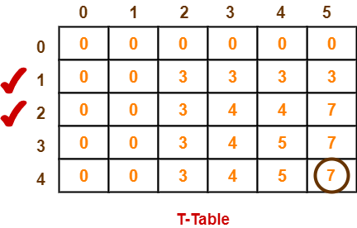

The last entry represents the maximum possible value that can be put into the knapsack.

* So, maximum possible value that can be put into the knapsack = 7.

### **Identifying Items To Be Put Into Knapsack-**

Last matrix value we got is 7.(i.e row 4)

Check the previous row(3) of same column,if the same value(7) is present – donot select that item.

Similarly check the previous row(2) , 7is also there, donot select

Check the previous row(1) ,7 is not there ,so select the row 2.

The profit of row 2 = 5,

so 7-5=3.

Now check for 3 , in previous row 1, ignore

Similarly check for 3 in row 0, it is not there so consider the previous row.

i.e considered items are -------- ( 1,1,0,0)

(w1, w2, w3, w4) = (2, 3, 4, 5)

(b1, b2, b3, b4) = (3, 4, 5, 6) , w = 5 kg

**knapsack problem-Dynamic Programming method**

**Algorithm :** knapsack(n,m,w,p,v)

//purpose : to find the optimal solution for the knapsack problem using dynamic programming

//input : n – number of objects to be selected

m – capacity of knapsack

w – weights of all the objects

p – profits of all objects

//output : v – the optimal solution for the number of objects selected with specified remaining capacity

for i <- 0 to n do

for j <- 0 to n do

if(i==0 or j==0)

v[i,j] = 0

else if (w[i]>j)

v[i,j]=v[i-1,j]

else v[i,j]=max(v[i-1,j],v[i-1,j-w[i]]+p[i])

endif

endfor

endfor

return

Algorithjm: Optimal(int m,int n,int w[],int v[][])

while(i!=0&&j!=0)

{

if(v[i][j]!=v[i-1][j])

{

x[i]=1;

j=j-w[i];

}

i=i-1;

}

**Time complexity :** Ə(mn)

**USING: b. Greedy Method**

## **Fractional Knapsack Problem-**

In Fractional Knapsack Problem,

As the name suggests, items are divisible here.

We can even put the fraction of any item into the knapsack if taking the complete item is not possible.

It is solved using Greedy Method.

Fractional knapsack problem is solved using greedy method in the following steps-

### **Step-01:**

 For each item, compute its value / weight ratio.

 S**tep-02:**

 Arrange all the items in decreasing order of their value / weight ratio.

**Step-03:**

 start putting the items into the knapsack beginning from the item with the highest ratio.

Put as many items as you can into the knapsack.

Find the optimal solution for the fractional knapsack problem making use of greedy approach. Consider-

n = 5

w = 60 kg

(w1, w2, w3, w4, w5) = (5, 10, 15, 22, 25)

(b1, b2, b3, b4, b5) = (30, 40, 45, 77, 90)

## **Solution-**

**Step-01:**

Compute the value / weight ratio for each item-

|  |  |  |  |
| --- | --- | --- | --- |
| **Items** | **Weight** | **Value** | **Ratio** |
| 1 | 5 | 30 | 6 |
| 2 | 10 | 40 | 4 |
| 3 | 15 | 45 | 3 |
| 4 | 22 | 77 | 3.5 |
| 5 | 25 | 90 | 3.6 |

**Step-02:**

 Sort all the items in decreasing order of their value / weight ratio-

**I1 I2 I5 I4 I3**

(6) (4) (3.6) (3.5) (3)

**Step-03**

Start filling the knapsack by putting the items into it one by one.

|  |  |  |
| --- | --- | --- |
| **Knapsack Weight** | **Items in Knapsack** | **Cost** |
| 60 | Ø | 0 |
| 55 | I1 | 30 |
| 45 | I1, I2 | 70 |
| 20 | I1, I2, I5 | 160 |

Now,

* Knapsack weight left to be filled is 20 kg but item-4 has a weight of 22 kg.
* Since in fractional knapsack problem, even the fraction of any item can be taken.
* So, knapsack will contain the following items-

**< I1 , I2 , I5 , (20/22) I4 >**

Total cost of the knapsack

= 160 + (20/27) x 77

= 160 + 70

= 230 units

Objects = 7, capacity=15kg

Profits=(10,5,15,7,6,18,3)

Weights=(2,3,5,7,1,4,1)

Calculate profit/weights of each item,i.e x

Select highest profit/weight

X=(5, 1.3, 3, 1, 6, 4.5, 3)

=(x1,x2,x3,x4,x5,x6,x7)

Greedy method- select the object and put the item in bag by selecting profit/weight. Highest value should be selected.

First include 5th object since highest value (x5)

Here weight is 1,profit=6

I,e 15-1=14

Next object is x1. Weight of object 1 is 2

I,e 14-2=12

Next is object 6, weight is 4.

I,e 12-4=8

Similarly 8-5= 3

3-1=2

Next is object 2, weight is 3,

But total remained capacity in the knapsack is 2,we cannot include full weight 3.

Therefore a fraction of object 2 is considered.

2 out of 3=2/3(fraction of object)

Object 4 is not included because bag is full

(1,2/3,1,0,1,1,1) are selected.

Now calculate the profit.

Multiplied the obtained capacity with individual weights – just to check the capacity of bag doesnot exceed 15kgs.

Sumof xiwi=(1*2+2/3*3+1*5+0*7+1*1+1*4+1*1)

=15

Similarly calculate the profit also

Sum of xiPi=(1*10+2/3*5+1*15+1*6+1*18+1*3)

=54.6

Greedy strategies to the 0/1 Knapsack problem:

Choose the items with as high a value per weight as possible.

**ALGORITHM**

GreedyAlgorithm (Weights [1 ...N], Values [1 ...N])

// Input: Array Weights contains the weights of all items

Array Values contains the values of all items

// Output: Array Solution which indicates the items are included in the knapsack (‘1’) or not (‘0’)

Integer CumWeight

Compute the value-to-weight ratios **ri=vi/wi**, i = 1, ..., N, for the items given.

Sort the items in non-increasing order of the value-to-weight ratios

for all items do

if the current item on the list fits into the knapsack then

place it in the knapsack

else

proceed to the next one

**7.From a given vertex in a weighted connected graph, find shortest paths to other vertices using Dijkstra's algorithm. Write the program in Java**.

**Theory:**

Dijkstra's algorithm solves the single-source shortest-path problem when all edges have nonnegative weights. It is a greedy algorithm and similar to Prim's algorithm. Algorithm starts at the source vertex, s, it grows a tree, T, that ultimately spans all vertices reachable from S. Vertices are added to T in order of distance i.e., first S, then the vertex closest to S, then the next closest, and so on. Following implementation assumes that graph G is

represented by adjacency lists.

**Algorithm:**

Input: A weighted connected graph G ={V,E}, source s

Output

dv: the distance-vertex matrix

• Read number of vertices of graph G

• Read weighted graph G

• Print weighted graph

• Initialize distance from source for all vertices as weight between source node and other vertices, i, and none in tree

//initial condition

• For all other vertices,

• dv[i] = wt_graph[s,i], TV[i]=0, prev[i]=0

• dv[s] = 0, prev[s] = s // source vertex

• Repeat for y = 1 to n v = next vertex with minimum dv value, by calling FindNextNear()

Add v to tree.

For all the adjacent u of v and u is not added to the tree,

if dv[u]> dv[v] + wt_graph[v,u]

then dv[u]= dv[v] + wt_graph[v,u] and prev[u]=v.

• findNextNear

//Input: graph, dv matrix

//Output: j the next nearest vertex

minm = 9999

For k =1 to n if k vertex is not selected in tree and

if dv[k] < minm { minm = dv [ k] j=k }

return j

Given Graph, find the shortest path from a source to all other vertices.

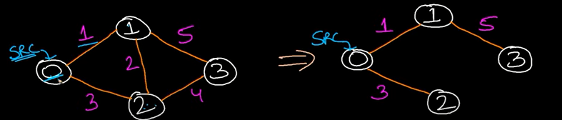

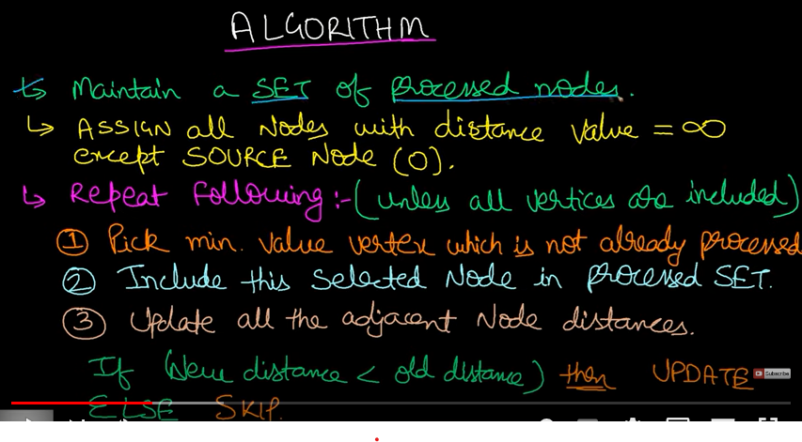

Algorithm: Initialize_single_source(V,s)

//This module will initialize distance vector d and update d in each iteration.

For each v belongs to V do

d[v] <- infinity

d[s] <- 0

end

Algorithm: relax: This module is to update the distance vector d when a shortest path is obtained as per greedy strategy.

If d[u]+w(u,v) < d[v]

We can improve the shortest path to v.

Update d[v], d[v] <- d[u]+w(u,v)

End algorithm

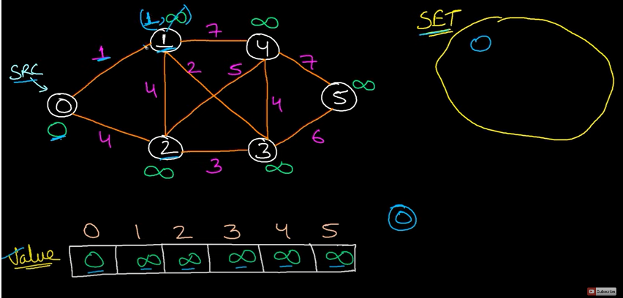

Update Node1: Cost at 1 is min(src node cost ,current node cost)= min((0+1)=>1,infinity)

Update Node 2: min((0+4)=>4,infinity)

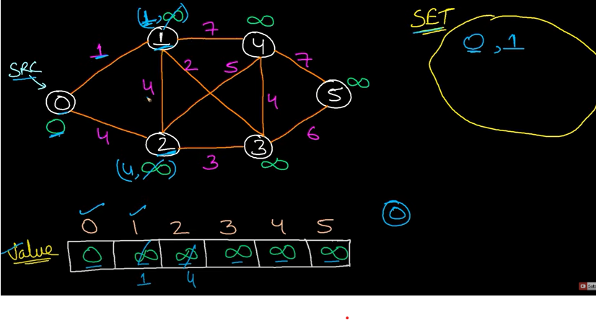

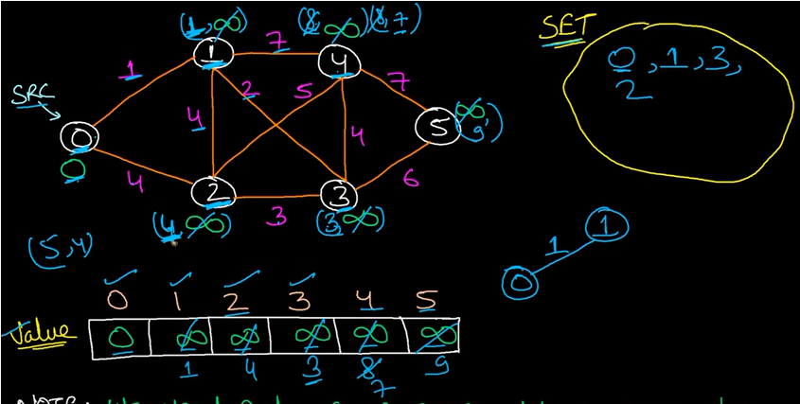

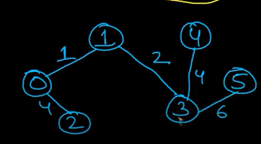

Time Complexity:

O(V2) //simple implementaion

O(E log V) //Adj List + Min heap

**SPANNING TREE:**

A spanning tree of an undirected graph is a connected subgraph that covers all the graph nodes with minimum possible edges.

**8. Find Minimum Cost Spanning Tree of a given connected undirected graph using Kruskal'salgorithm. Use Union-Find algorithms in your program.**

Kruskal’s algorithm is the concept that is introduced in the graph theory.

It is used to discover the shortest path between two points in a connected weighted graph.

This [algorithm](https://www.simplilearn.com/data-structures-and-algorithms-article) converts a given graph into the forest, considering each node as a separate tree. These trees can only link to each other if the edge connecting them has a low value and doesn’t generate a cycle in MST structure.

The Kruskal algorithm is used to generate a minimum [spanning tree](https://www.simplilearn.com/tutorials/data-structure-tutorial/spanning-tree-in-data-structure) for a given graph.

A minimum spanning tree is a subset of a graph with the same number of vertices as the graph and edges equal to the number of vertices -1. It also has a minimal cost for the sum of all edge weights in a spanning tree.

Kruskal’s algorithm sorts all the edges in **increasing order of their edge weights** and keeps **adding nodes to the tree only if the chosen edge does not form any cycle**. Also, it picks the edge with a minimum cost at first and the edge with a maximum cost at last. Hence, you can say that the Kruskal algorithm makes a locally optimal choice, intending to find the global optimal solution. That is why it is called a [Greedy Algorithm.](https://www.simplilearn.com/tutorials/data-structure-tutorial/greedy-algorithm)

## Creating Minimum Spanning Tree Using Kruskal Algorithm

Let us first look into the steps involved in Kruskal’s Algorithm to generate a minimum spanning tree:

* Step 1: Sort all edges in increasing order of their edge weights.
* Step 2: Pick the smallest edge.
* Step 3: Check if the new edge creates a cycle or loop in a spanning tree.
* Step 4: If it doesn’t form the cycle, then include that edge in MST. Otherwise, discard it.
* Step 5: Repeat from step 2 until it includes |V| - 1 edges in MST.

## What Is Union Find Algorithm?

## Any MST algorithm revolves around determining whether adding an edge would result in a loop or not. Union Find is the most popular algorithm for determining this. The Union-Find algorithm separates vertices into clusters, allowing you to determine whether two vertices belong to the same cluster and hence if adding an edge will produce a cycle.

Union Find is an algorithm that keeps track of elements that are split into one or over one disjoint set. It has two primary operations: Find and Union.

The Find operation returns the set of elements to which the given element (argument) belongs, whereas the Union operation merges two disjoint sets.

Steps to be followed Kruskal algoritm:

**DISJOINT SETS:**

**A disjoint–set is a data structure that keeps track of a set of elements partitioned into several disjoint (non-overlapping) subsets.**

Two or more sets with nothing in common is called disjoint sets.

EX: let’s have 5 elements and it is divided into two sets. S1= {1,2,3} ,S2={4,5}

Here S1 and S2 are disjoint sets, nothing in common.

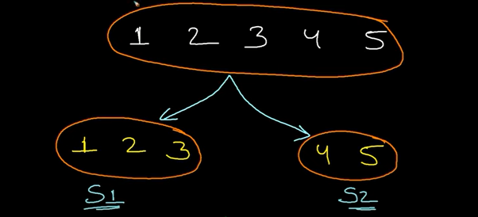

Uses of Disjoint Sets:

1. It is easier to check given 2 elements whether they belong to same subset or not.

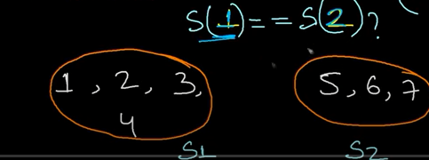

Here to check if element 1 and element2 belong to same set or not.

Here 1 and 2 belong to same set (S1)

**FIND operation**

1. Used to merge two sets into one ( UNION operation)

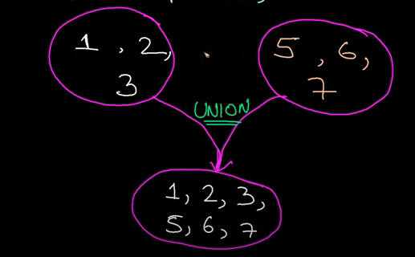

Disjoint sets uses chaining to define a set. The Chaining is defined by a **Parent-child relationship.**

**Ex: if we have 3 elements. Tree can be represented .**

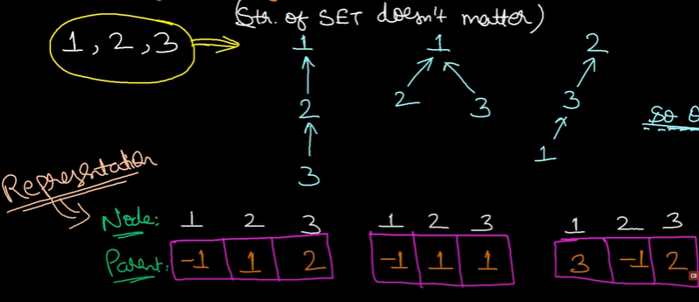

Which ever the structure is there, A **single absolute root**.Absolute root should be defined.

**Representation of the structure in the form of Array:**

Indices of an array can be indicated as Node, and what ever values they store will be parent values to which they are pointing to.

**Two Sets Representation: Skew tree**

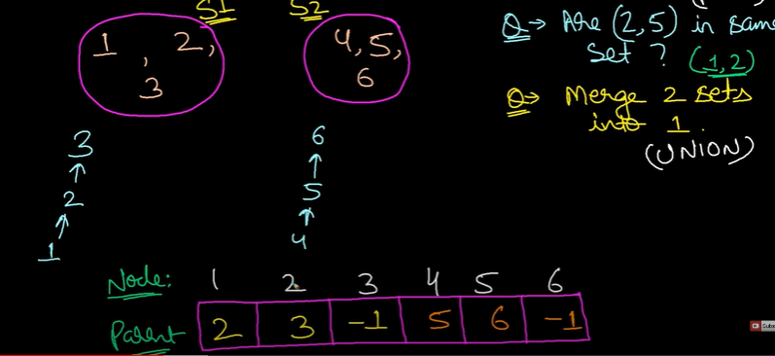

Ex: **Find Operation:** Are (2, 5) are in same set or not?

Ans : Find the absolute root of 2 and absolute root of 5, if they belong to same set,it results to TRUE.

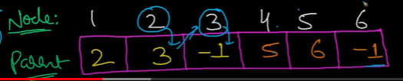

Absolute root of 2 is **3**

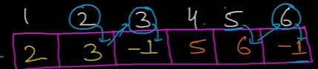

**Absolute root of 5 is 6**

They are not in same set.

**FIND Operation :**If the root parent of A and B are same then they must be in the same SET.

**UNION of 2 sets:**

-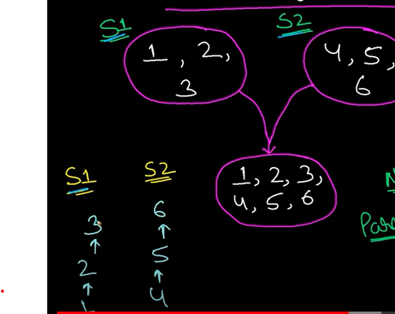

**UNION(1,5)**

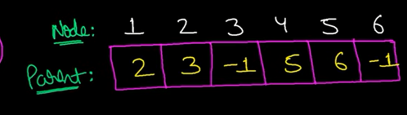

Find the absolute root of 1 and 5.

Merge two sets.

EXAMPLE:

To detect cycle in undirected graph(Disjoint sets cannot detect cycle in directed graph)

Given edge list of the graph

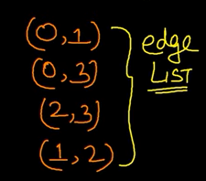

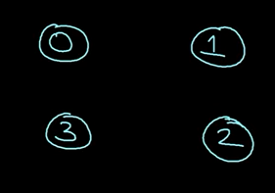

Initially we have not processed any edges. Here array for the disjoint set representation.

Initially all the nodes are separate.they have not joined any where.

Each and every node are basically the absolute root of itself,because each and every tree is having a single node ,all the values are-1.

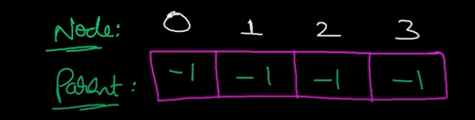

Process the first edge**: (0,1) –process it,check if in same set or not.**

-here 0 and 1 are absolute root of itself. They must be in different sets.

Then find the UNION of them.-pointing one absolute root to another.

Here 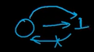 zero is pointing to 1.

Replace parent of 0 with 1.

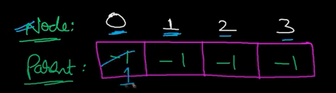

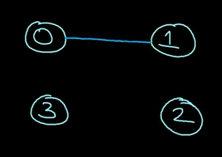

Now take the edge (0,3)and process :

Absolute root of 0 = 1

Absolute root of 3 =3

Different AR,They both are in different sets. Take union of (0,3).

Taking union(1,3) –pointing 1 to 3 or 3 to 1.

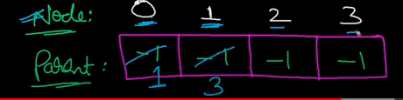

(0,1,3) are in same set

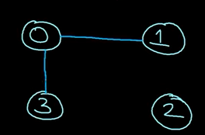

Take edge(2,3) => Find the absolute root of 2 and 3 as 2 and 3,they belong to different sets.

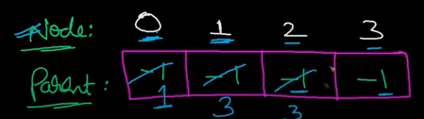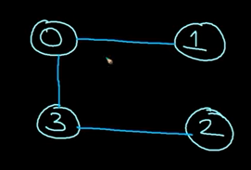

Now there is no cycle.

**Kruskal's Algorithm**

Start with an empty set A, and select at every stage the shortest edge that has not been chosen or rejected, regardless of where this edge is situated in graph.

_ Initially, each vertex is in its own tree in forest.

_ Then, algorithm considers each edge in turn, order by increasing weight.

_ If an edge (*u*, *v*) connects two different trees, then (*u*, *v*) is added to the set of edges of the

MST, and two trees connected by an edge (*u*, *v*) are merged into a single tree.

_ On the other hand, if an edge (*u*, *v*) connects two vertices in the same tree, then edge (*u*, *v*) is discarded.

Kruskals algorithm can be implemented using **disjoint set** data structure or **priority queue** data structure.

Kruskal's algorithm implemented with disjoint-sets data structure.

**Disjoint-Sets Data Structure**

• Make_Set (*v*)

Create a new set whose only member is pointed to by *v*. Note that for this operation v must

already be in a set.

• FIND_Set

Returns a pointer to the set containing *v*.

• UNION (*u*, *v*)

Unites the dynamic sets that contain *u* and *v* into a new set that is union of these two sets

**MST_KRUSKAL (G, w)**

1. A _ {} // A will ultimately contains the edges of the MST

2. for each vertex v in V[G]

3. do Make_Set (*v*)

4. Sort edge of E by nondecreasing weights w

5. for each edge (*u*, *v*) in E

6. do if FIND_SET (*u*) _ FIND_SET (*v*)

7. then A = AU{(*u*, *v*)}

8. UNION (*u*, *v*)

9. Return A

**Time efficiency: O(E * V) or O(Elog E + E log V)**

**Process all edges , FIND or UNION worst case in skewed tree**

**9. Find Minimum Cost Spanning Tree of a given connected undirected graph using Prim's algorithm.**

**Theory:**

Choose a node and build a tree from there selecting at every stage the shortest available edge that can extend the tree to an additional node.

• Prim's algorithm has the property that the edges in the set A always form a single tree.

• We begin with some vertex v in a given graph G =(V, E), defining the initial set of vertices A.

• In each iteration, we choose a minimum-weight edge (u, v), connecting a vertex v in the set A to the vertex u outside of set A.

• The vertex u is brought in to A. This process is repeated until a spanning tree is formed.

• Like Kruskal's algorithm, here too, the important fact about MSTs is we always choose the smallest-weight edge joining a vertex inside set A to the one outside the set A.

• The implication of this fact is that it adds only edges that are safe for A; therefore when the algorithm terminates, the edges in set A form a MST

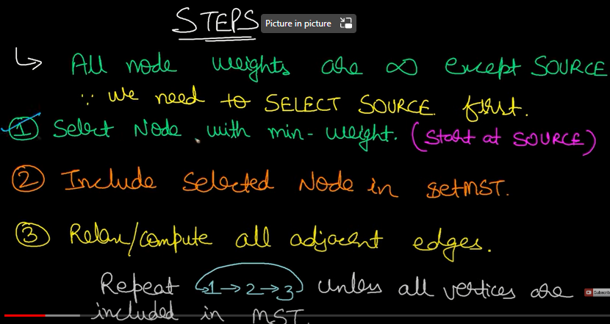

Step 1: Source node is set to zero, all other nodes to infinity.

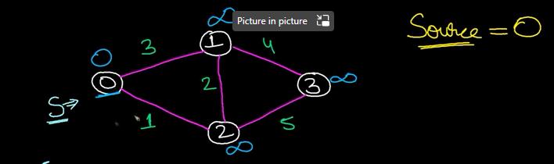

Step 2: which ever node is already processed ,we will not process it again.Duplicate nodes can be avoided.

Since source node is 0.

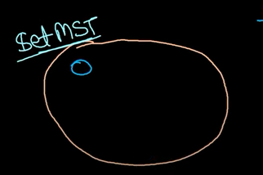

Step 3: Updates the cost of the edges

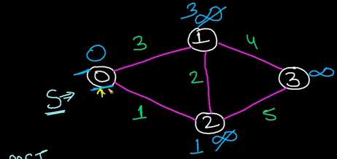

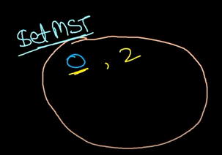

Select node 2 now.



From 2 find the adjacent nodes, node 0 is already entered ,check for next adjacent node,

It is 1 because of least edge. 3 is also adjacent-change infinity to 5.

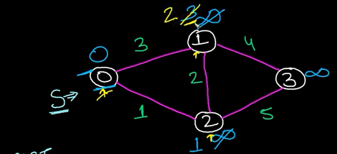

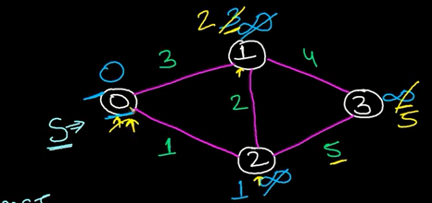

Add1 to min spanning tree.:

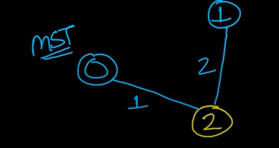

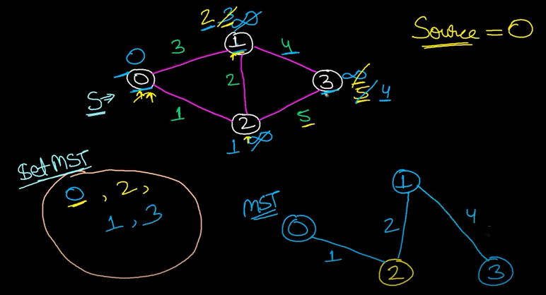

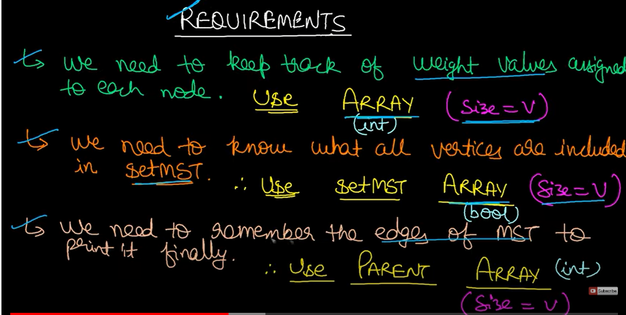

**Pseudo Code:**

MST_PRIM (G, w, v)

1. Q V[G]

2. for each u in Q do

3. key [u] = infinity

4. key [r] = 0

5. pi[r]= NIl

6. while queue is not empty do

7. u = EXTRACT_MIN (Q)

8. for each v in Adj[u] do

9. if v is in Q and w(u, v) < key [v]

10. then pi[v] = w(u, v)

11. key [v] = w(u, v)

10. Write Java programs to

(a) Implement All-Pairs Shortest Paths problem using **Floyd's algorithm**.

(b) Implement **Travelling Sales Person problem** using Dynamic programming.

**All Pairs Shortest Path Problem:**

**“The all pair shortest path algorithm is used to find all pair shortest path problem from a given weighted graph. As a result of this algorithm, it will generate a matrix, which will represent the minimum distance from any node to all other nodes in the graph”**

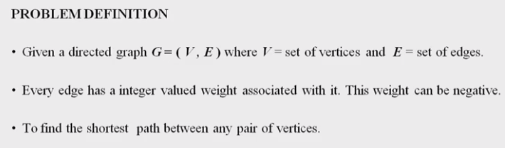

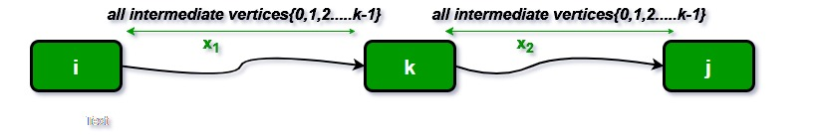

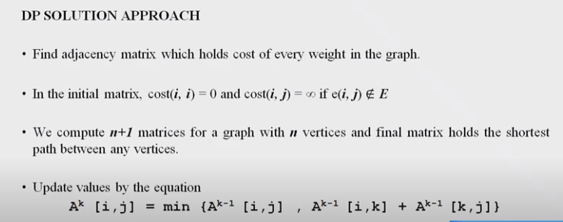

**Complexity**

The asymptotic complexity of Floyd algorithm is O(n3).

**Problem:**

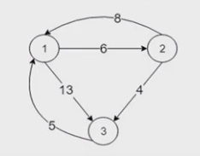

Initial Distance matrix of the given graph(Initial Matrix)

Step1:

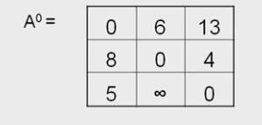

Step2: Consider 1st row and 1st column

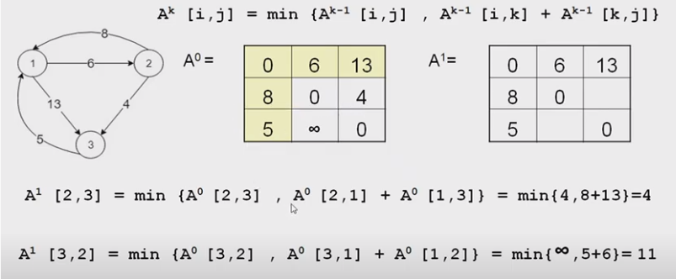

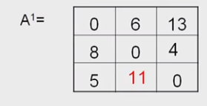

Step3:Consider Row 2 and Column 2

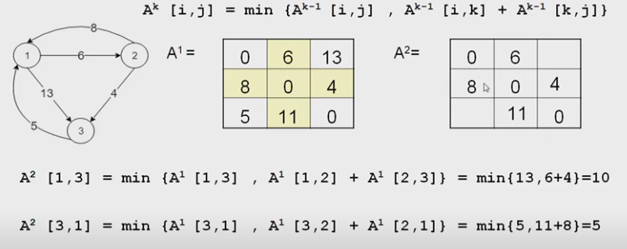

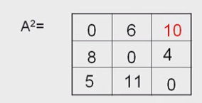

Step4: Consider Row3 and Column3

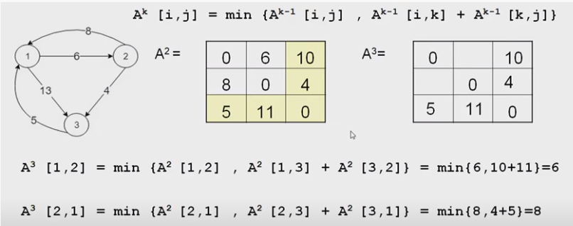

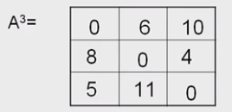

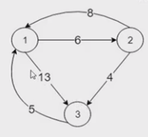

Initial Distances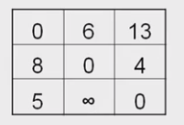

Final Distances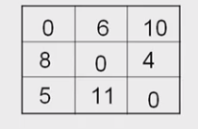

**Algorithm:**

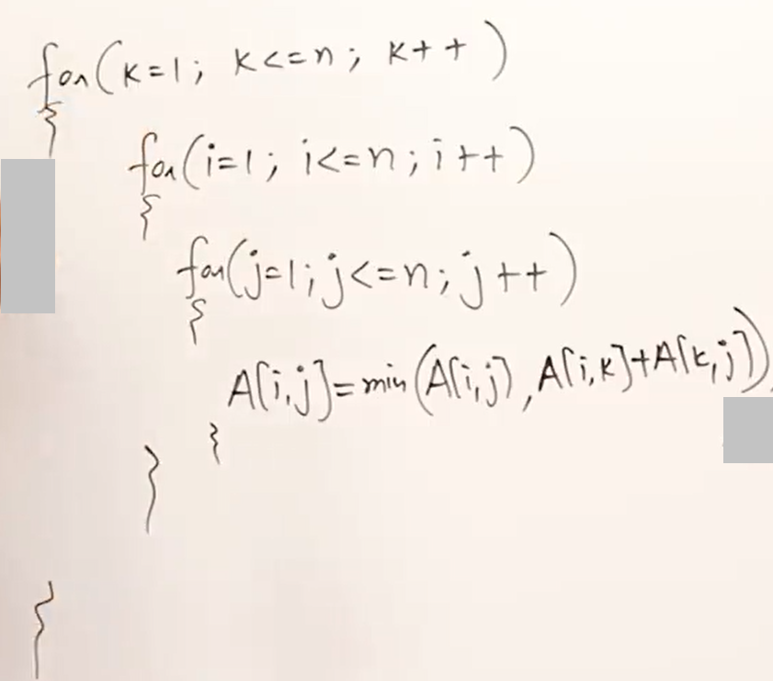

**Time Efficiency: O(n3)**

**Travelling SalesPerson Problem:**

## Problem Statement

In the TSP, given a set of cities and the distance between each pair of cities, a salesman needs to choose the shortest path to visit every city exactly once and return to the city from where he started.

In this algorithm, we take a subset of the required cities needs to be visited, distance among the cities  and starting city  as inputs. Each city is identified by unique city id like .

Initially, all cities are unvisited, and the visit starts from the city . We assume that the initial travelling cost is equal to . Next, the TSP distance value is calculated based on a recursive function. If the number of cities in the subset is two, then the recursive function returns their distance as a base case.

On the other hand, if the number of cities is greater than , then we’ll calculate the distance from the current city to the nearest city, and the minimum distance among the remaining cities is calculated recursively.

Finally, the algorithm returns the minimum distance as a TSP solution.

**PROBLEM:**

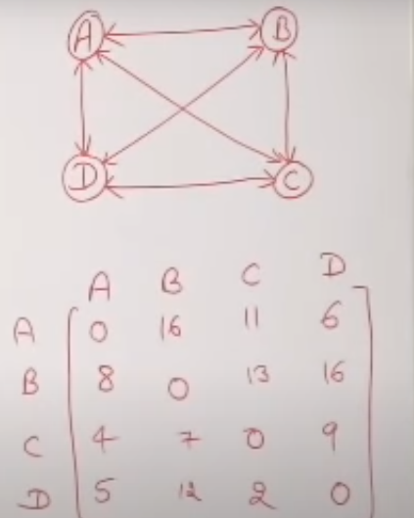





**Time efficiency: O(N2 * 2n )**

**11. Design and implement in Java to find a subset of a given set S = {Sl, S2,.....,Sn} of *n* positive integers whose SUM is equal to a given positive integer *d*. For example, if S ={1, 2, 5, 6, 8} and *d*= 9, there are two solutions {1,2,6}and {1,8}. Display a suitable message, if the given problem instance doesn't have a solution.**

**Backtracking:**

These algorithms determine the problem solutions by systematically searching the **solution space** for the given problem instance.

**• Algorithm:**

• accept n: no of items in set

• accept their values, sk in increasing order

• accept d: sum of subset desired

• initialise x[i] = -1 for all i

• check if solution possible or not

• if possible then call SumOfSub(0,1,sum of all elements)

Go through all possible configurations of the search space.

## Algorithm: Subset(s, k, r)

1. //Values of x[ j ], 1 <= j < k, have been determined
2. //Node creation at level k taking place: also call for creation at level K+1 if possible
3. // s = sum of 1 to k-1 elements and r is sum of k to n elements
4. //generating left child that means including k in solution

//create left child with kth element

1. x[k]=1
2. if(s+w[k]==d) then subset found, print solution
3. for(int i=0;i<=k;i++)
4. if(x[i]==1)
5. print w[i]
7. else if((s+w[k]+w[k+1])<=d)
8. Subset(s+w[k],k+1,r-w[k]);

//create right child with out kth object

1. if((s+r-w[k])>=d&&(s+w[k+1])<=d)
2. {
3. x[k]=0;
4. Subset(s,k+1,r-w[k]);
5. }
7. end Subset

**T(n)    =   O(2n)**

W1=2, W2=4, W3=6 ,S=6

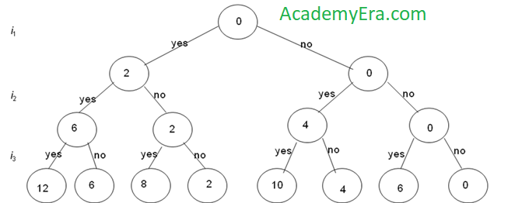

**12. Design and implement in Java to find all Hamiltonian Cycles in a connected undirected Graph G of *n* vertices using backtracking principle.**

**Theory:**

Hamiltonian Path in an undirected graph is a path that visits each vertex exactly once. A Hamiltonian cycle (or Hamiltonian circuit) is a Hamiltonian Path such that there is an edge (in graph) from the last vertex to the first vertex of the Hamiltonian Path. Determine whether a given graph contains Hamiltonian Cycle or not. If it contains, then print the path. Following are the input and output of the required function.

***Input:***

A 2D array graph[V][V] where V is the number of vertices in graph and graph[V][V] is adjacency matrix

representation of the graph. A value graph[i][j] is 1 if there is a direct edge from i to j, otherwise graph[i][j] is 0.

***Output:***

An array path[V] that should contain the Hamiltonian Path. path[i] should represent the vertex i in the Hamiltonian Path. The code should also return false if there is no Hamiltonian Cycle in the graph.

**Algorithm:**

hamiltonian(p,index)

if index>n then

path is complete display the values in p

else

for each node v in G

if v can be added to the path then

add v to path p and call hamiltonian(p,index+1)

end hamiltonian